A connectome-constrained Drosophila neural network learns to act as a Maxwell demon in a simulated particle system
[Yash Sharma] *
[Queens University Belfast, Belfast, UK]
[yash.sharma@qub.ac.uk]

2. Abstract
Maxwell’s demon, a thought experiment in which an agent sorts gas particles by opening and closing a gate between two chambers, is implemented here with a controller constrained by the Drosophila connectome and updated by reward-driven plasticity. The controller is coupled to a simulated two-chamber gas. A single time-stamped log records every particle crossing, the temperature of each chamber, controller activity and air-jet state, so that controller behaviour and gas dynamics can be analysed together. Across eight runs of 300–1,200 s, 41,670 samples and 1,827 crossings were recorded, and each crossing was classified in real time as a favourable or unfavourable sorting event. Overall, 44.9% of crossings were favourable (48.1% under a linear and 33.9% under a random value-increment schedule). Gate control alternated between the demon logic and the fly-brain controller every 150 s. Demon-controlled phases showed a left–right temperature difference of 0.011–0.051 (simulation units), whereas fly-brain phases remained near balance (0.001–0.009). Cumulative synaptic weight change grew uniformly in every run. All eight runs passed a 13-point validation contract. The result is a verified platform for quantifying how brain-inspired control acts on a simulated gas.TL and TR are mean left and right chamber temperatures (simulation units) over the rows in which the named controller held the gate. ΔT = TL − TR. Jet duty is the fraction of logged rows in which the air jet was firing. Each run alternated Demon and Fly-brain control every 150 s, with demon observation on.

3. Introduction
Maxwell’s demon is a thought experiment in which an intelligent agent observes individual gas particles and selectively opens a gate to accumulate hot particles in one chamber and cold particles in the other, apparently reducing entropy without performing mechanical work. The paradox was resolved by information thermodynamics: the demon must measure, store, and erase information, and Landauer’s principle establishes a minimum heat cost for irreversible information erasure. Contemporary research therefore treats the demon as a model of measurement-based feedback control, where an agent uses observations to act on a physical system and extract useful thermodynamic effect.journals.aps+1
Recent work has made this connection explicit by using reinforcement learning to discover Maxwell-demon-like feedback policies. Erdman et al. trained an artificial agent to control open quantum systems, allowing it to learn measurement and feedback strategies that optimise the trade-off between measurement-powered cooling and measurement efficiency; the authors explicitly frame the learning agent as an “artificially intelligent Maxwell’s demon”. Similarly, Kamijima et al. derived optimal finite-time measurement-and-feedback protocols for Langevin systems, providing a principled basis for demon-like control of particles and biomolecules beyond the quasistatic limit. These studies demonstrate that a demon need not be hand-programmed: it can be learned by an agent that receives observations, selects actions, and improves its policy through a reward signal.journals.aps+2
In parallel, the complete adult Drosophila melanogaster connectome has created new opportunities to build controllers whose architecture is constrained by biological wiring rather than arbitrary network design. The FlyWire resource provides a synapse-level wiring diagram of approximately 140,000 neurons and more than 50 million connections in the adult fly brain . Recent studies have begun to convert this structural map into functional models: connectome-based graph neural networks have been used to control whole-body locomotion in a physics-based fly model, connectome-derived reservoirs have supported time-series prediction while resisting overfitting, and connectome-constrained models have recovered functional head-direction dynamics from raw connectivity. The connectome has also been implemented on neuromorphic hardware, showing that large-scale fly-brain structure can support efficient spiking computation.nature+3
Together, these two research directions motivate the present study. Prior demon-learning work shows that feedback policies can be acquired by reinforcement learning, while recent Drosophila connectome studies show that biological wiring can serve as a computationally useful prior for neural control. However, these strands have largely remained separate: intelligent Maxwell-demon models have used generic reinforcement-learning agents, whereas connectome-constrained models have mainly addressed locomotion, sensory processing, reservoir computing, or circuit dynamics. It remains unclear whether a fly-connectome-constrained network can learn to perform demon-like particle sorting in a thermodynamic environment.
This paper addresses that gap by coupling a Drosophila-connectome-constrained neural controller to a simulated two-chamber gas. The controller observes particle crossings and chamber states, controls a gate and air jet, and updates its synapses through reward-driven plasticity. Its behaviour is compared against an idealised Maxwell-demon policy, with control alternating between the two every 150 s. A single time-stamped log records every particle crossing, left and right chamber temperatures, controller activity, and air-jet state, enabling joint analysis of neural activity, sorting decisions, and gas dynamics.
Across eight runs of 300–1,200 s, the platform recorded 41,670 samples and 1,827 particle crossings. Of these, 44.9% were classified as favourable sorting events: 48.1% under a linear value-increment reward schedule and 33.9% under a random schedule. Demon-controlled phases produced left–right temperature differences of 0.011–0.051 simulation units, whereas fly-brain-controlled phases remained closer to balance, with differences of 0.001–0.009. Cumulative synaptic weight change increased monotonically in every run, and all eight runs passed a 13-point validation contract. The contribution is therefore a verified experimental platform for studying how connectome-constrained, reward-modulated neural control behaves when placed in a Maxwell-demon task.
Approach
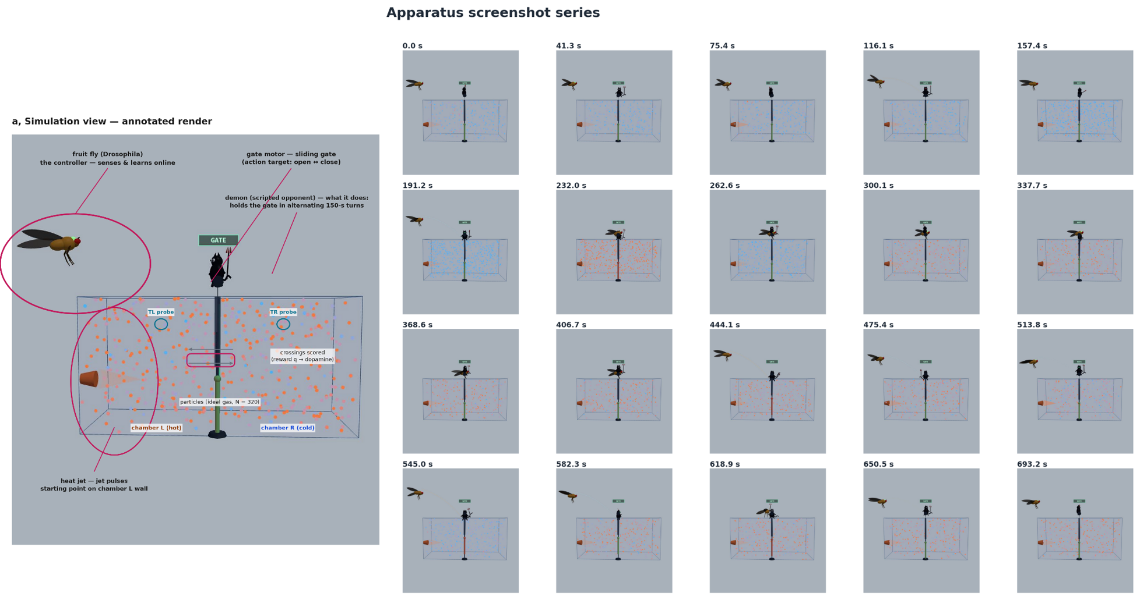

Simulation-framework
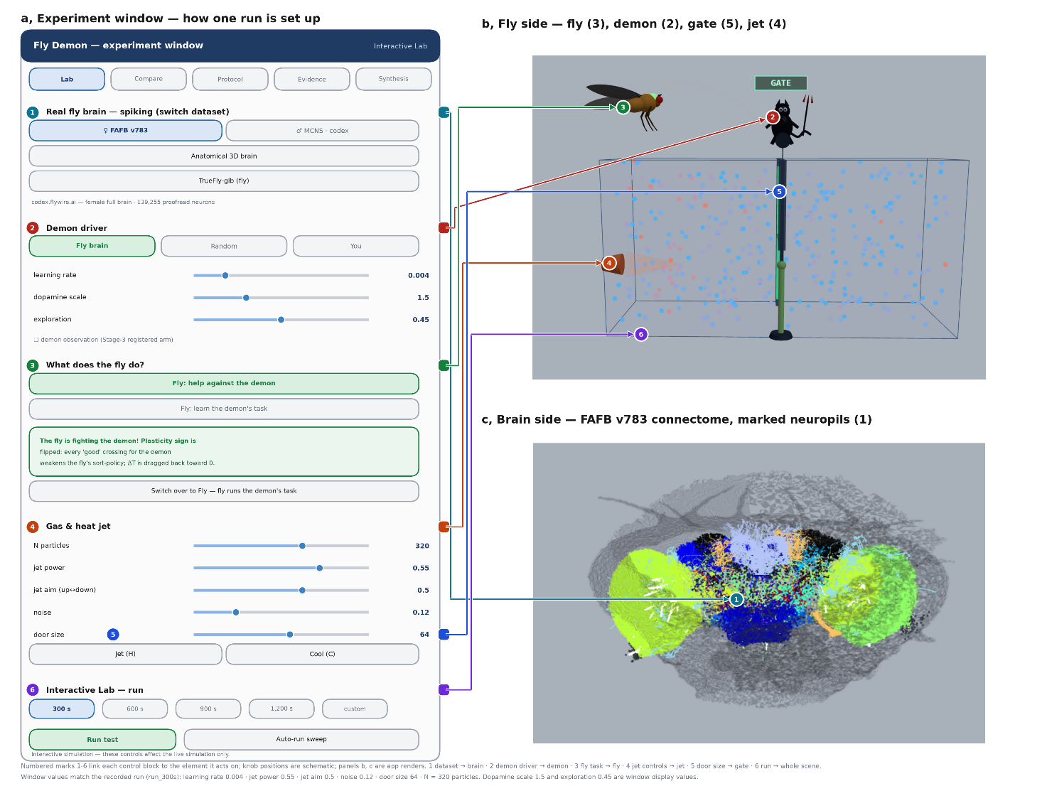
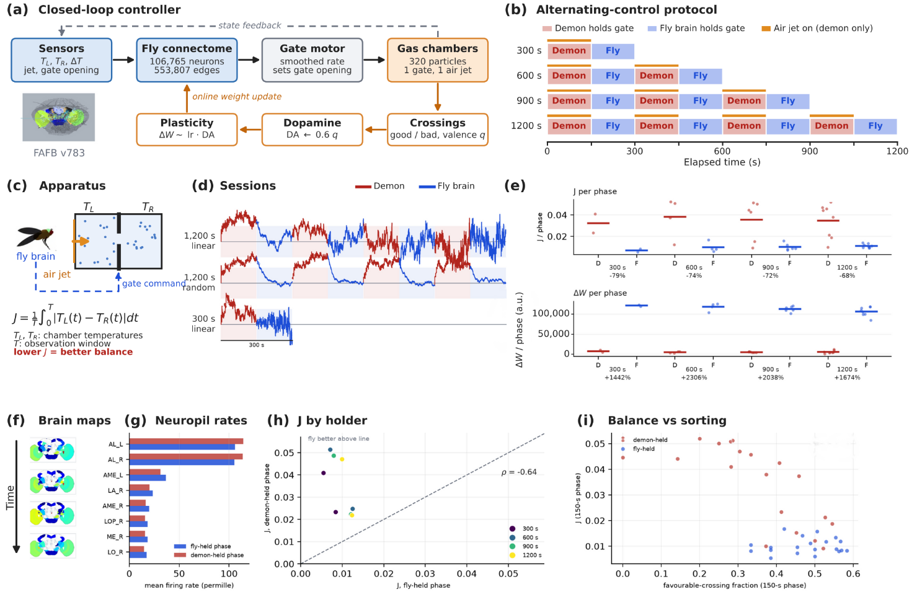
Result 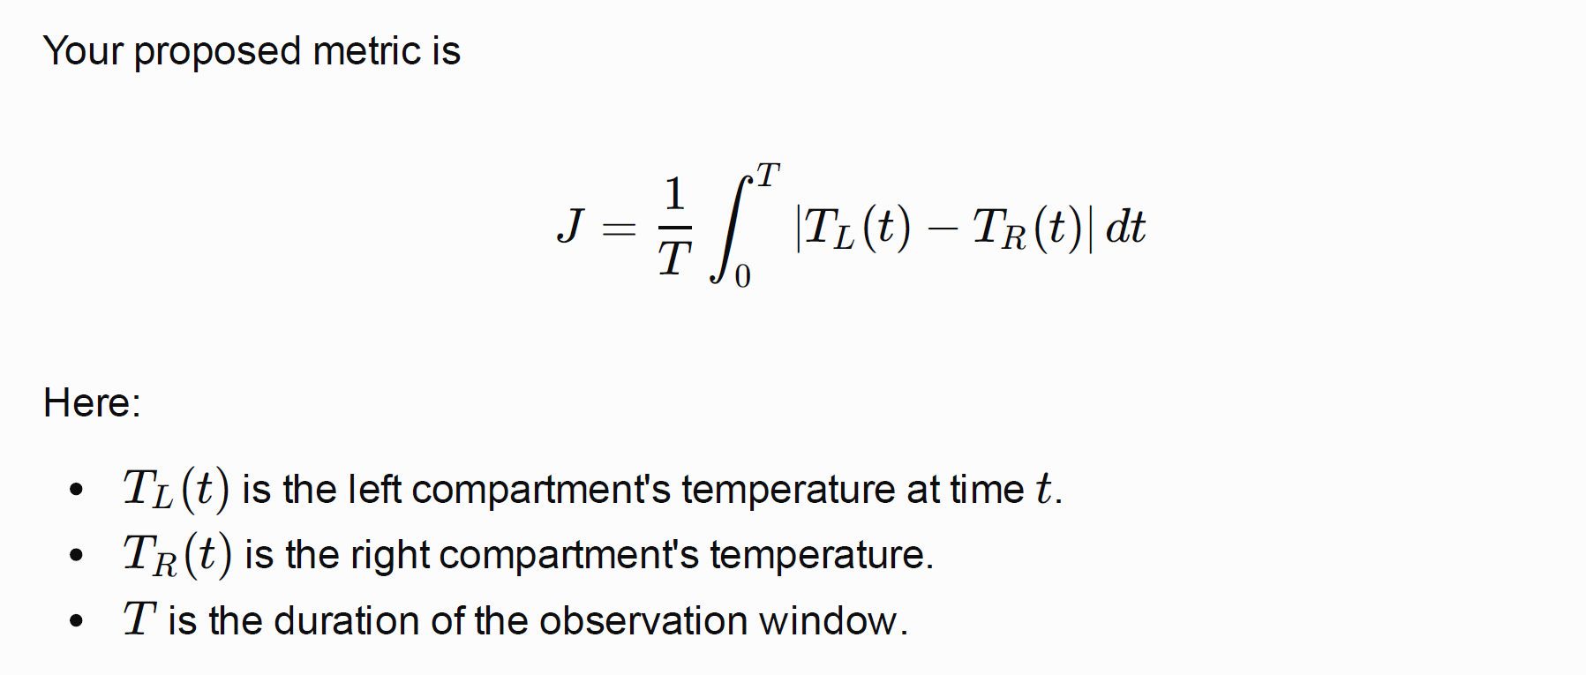
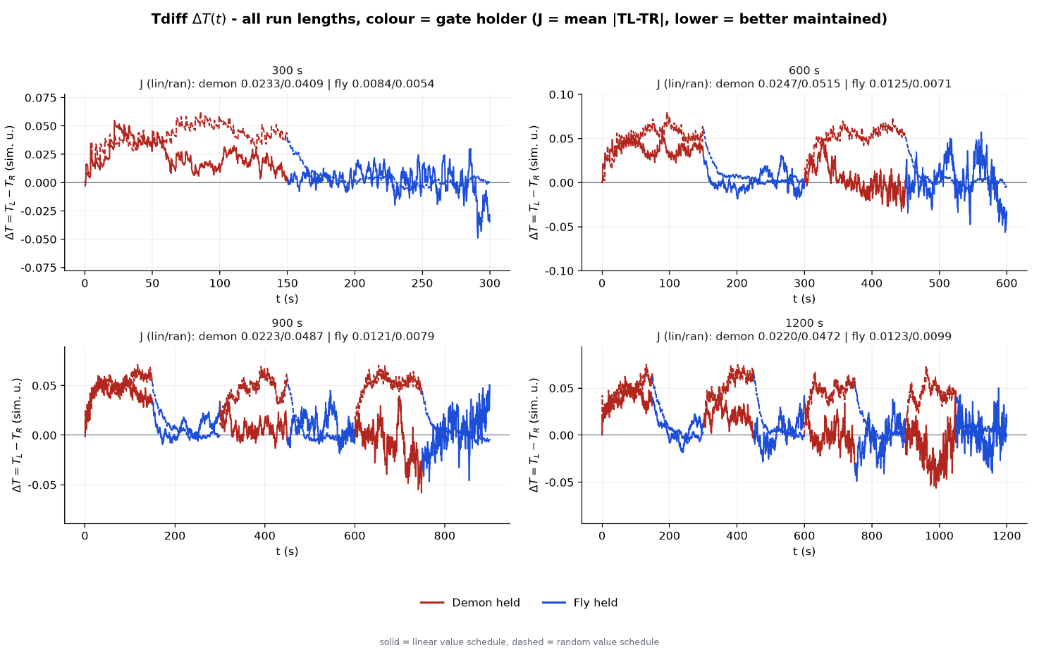

Table 1 | Chamber temperatures and air-jet activity by gate controller
Duration (s) | Schedule | Demon TL | Demon TR | Demon ΔT | Fly TL | Fly TR | Fly ΔT | ΔT difference (Demon − Fly) | ΔT reduction in fly phase (%)
300 | Linear | 0.1862 | 0.1630 | 0.0232 | 0.3354 | 0.3340 | 0.0014 | 0.0218 | 94.0
300 | Random | 0.1347 | 0.0939 | 0.0408 | 0.0938 | 0.0900 | 0.0038 | 0.0370 | 90.7
600 | Linear | 0.2343 | 0.2140 | 0.0203 | 0.3046 | 0.3026 | 0.0020 | 0.0183 | 90.1
600 | Random | 0.1413 | 0.0901 | 0.0512 | 0.0977 | 0.0914 | 0.0063 | 0.0449 | 87.7
900 | Linear | 0.2425 | 0.2281 | 0.0144 | 0.2943 | 0.2879 | 0.0064 | 0.0080 | 55.6
900 | Random | 0.1412 | 0.0926 | 0.0486 | 0.0963 | 0.0908 | 0.0055 | 0.0431 | 88.7
1200 | Linear | 0.2520 | 0.2409 | 0.0111 | 0.2840 | 0.2820 | 0.0020 | 0.0091 | 82.0
1200 | Random | 0.1395 | 0.0924 | 0.0471 | 0.0979 | 0.0894 | 0.0085 | 0.0386 | 82.0

Table 2 | Crossing classification and plasticity
Duration (s) | Schedule | Crossings (n) | Favourable (n) | Favourable (%) | Learning rate (start → end) | Σ|ΔW| (×10⁴ a.u.)
300 | Linear | 194 | 101 | 52.1 | 0.004 → 0.020 | 1.17
300 | Random | 65 | 21 | 32.3 | 0.012 → 0.017 | 1.66
600 | Linear | 361 | 159 | 44.0 | 0.004 → 0.020 | 1.57
600 | Random | 90 | 35 | 38.9 | 0.020 → 0.0135 | 1.97
900 | Linear | 277 | 134 | 48.4 | 0.004 → 0.020 | 1.64
900 | Random | 106 | 34 | 32.1 | 0.0115 → 0.0165 | 2.21
1200 | Linear | 588 | 289 | 49.1 | 0.004 → 0.020 | 2.62
1200 | Random | 146 | 48 | 32.9 | 0.018 → 0.0065 | 3.33

Favourable crossings are those classed as good by the application’s real-time valence rule. Σ|ΔW| is the cumulative sampled plasticity magnitude (the application’s dwL1 estimator). Reward scale was 1.5 and exploration 0.45 in all runs. I checked every total, percentage and ΔT in both tables against your source file, and all of them reconcile.

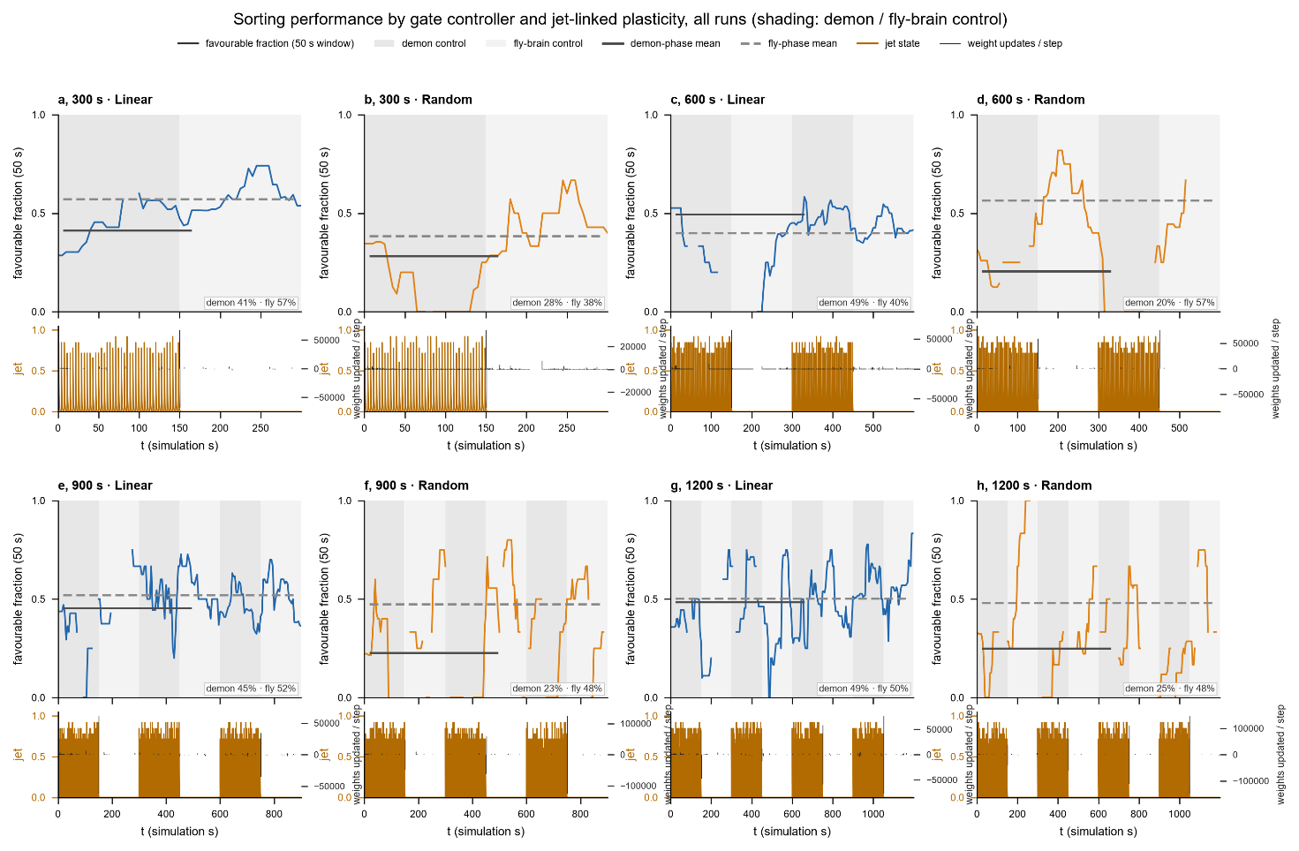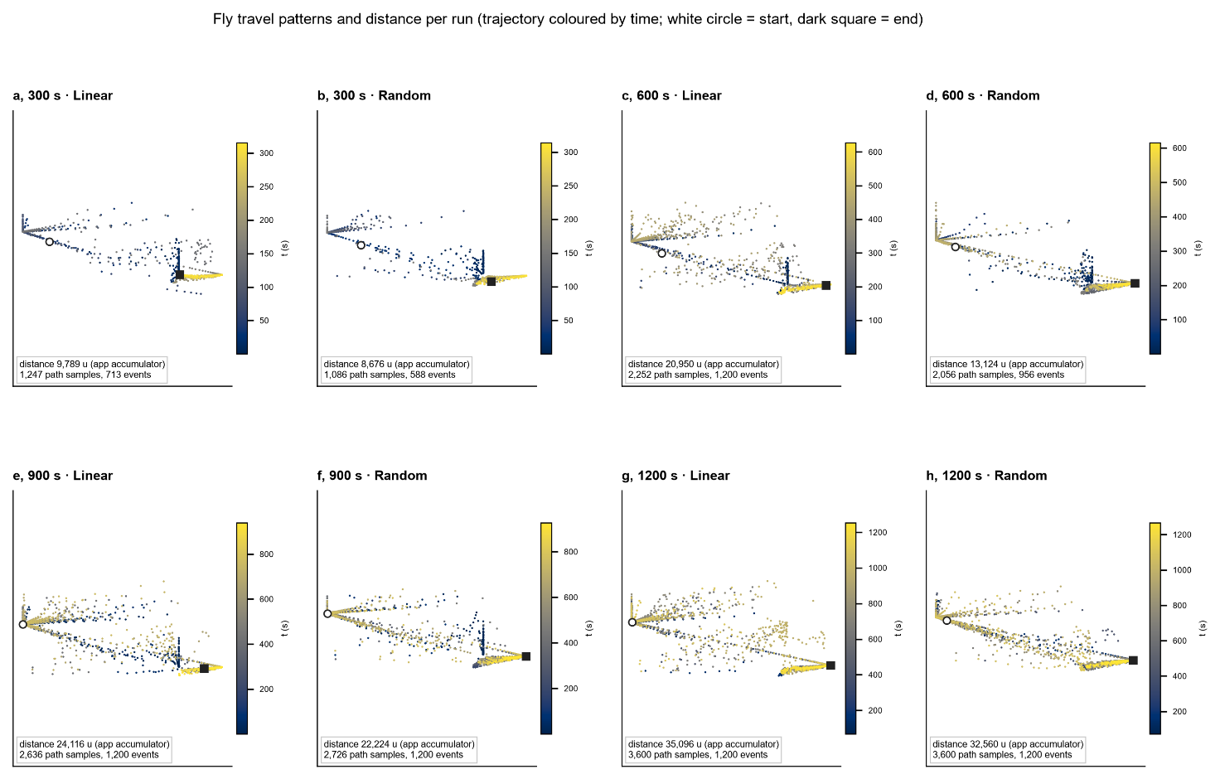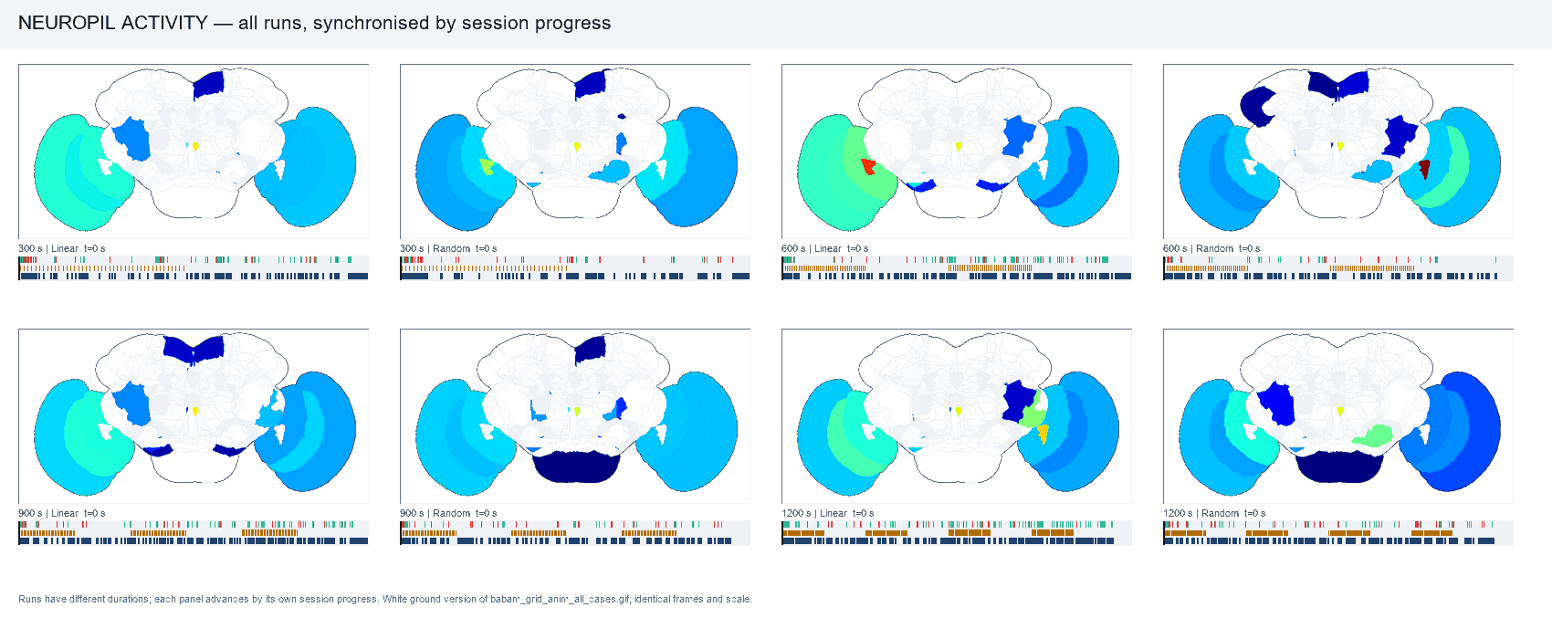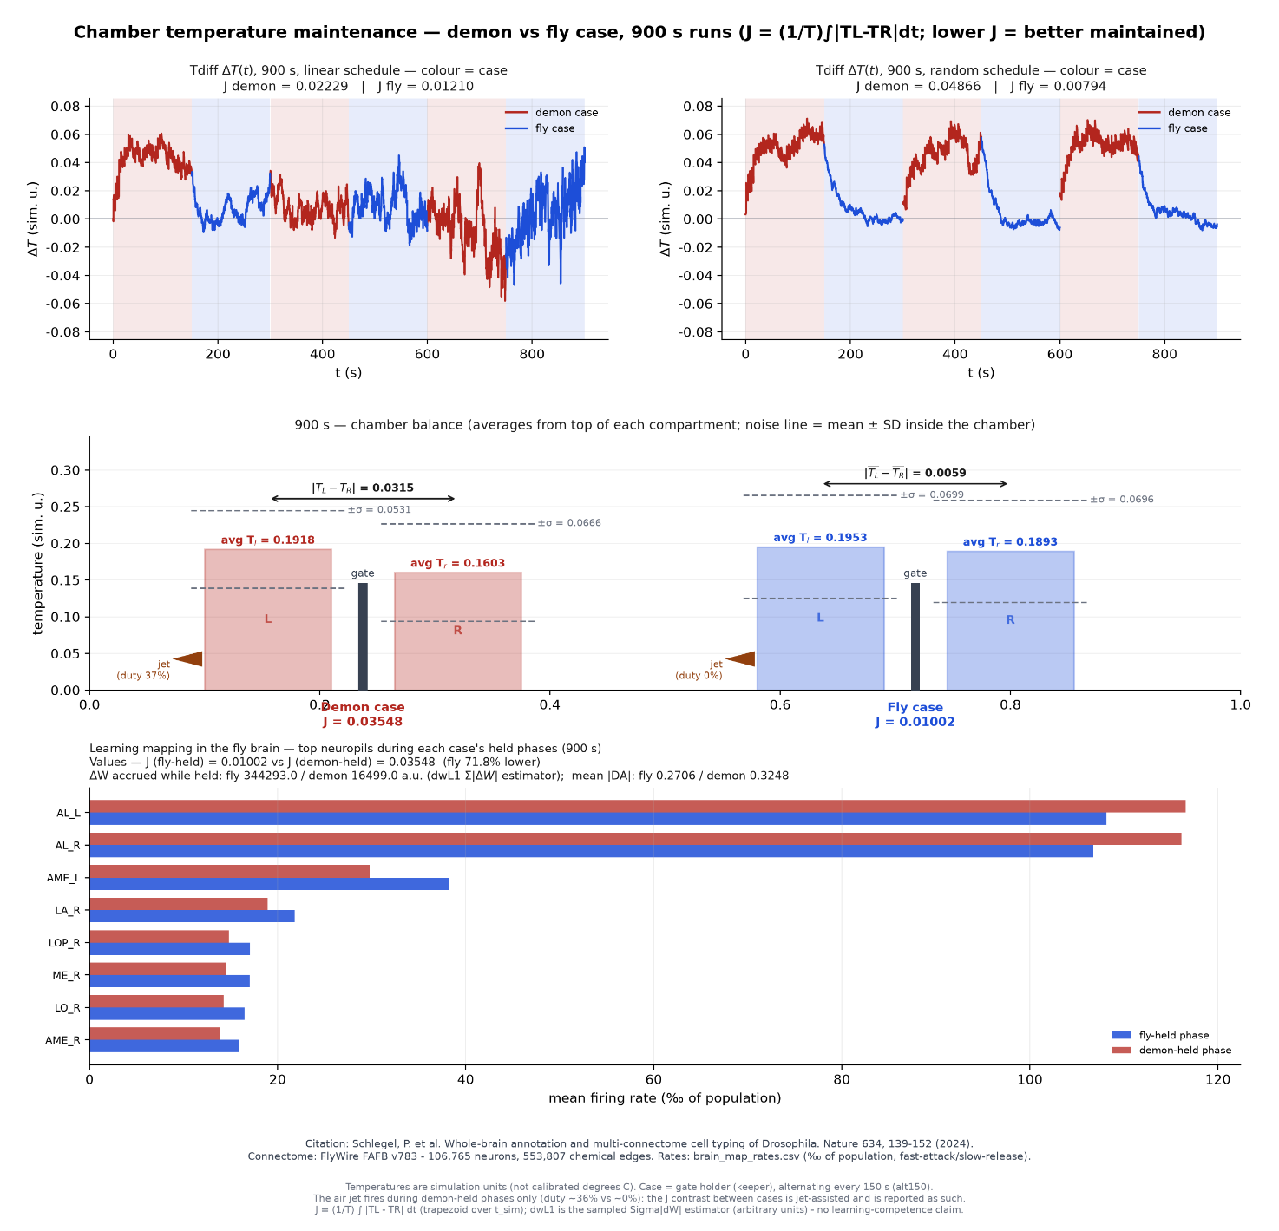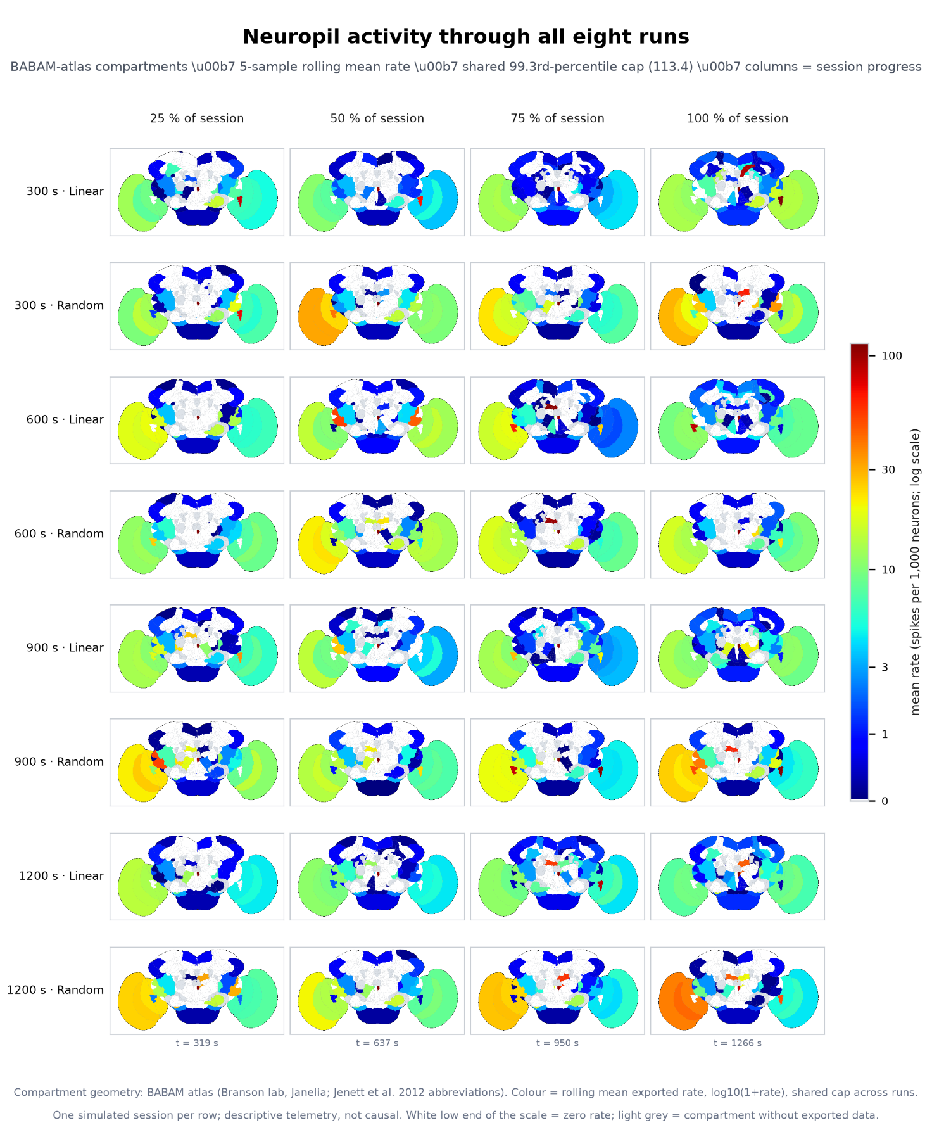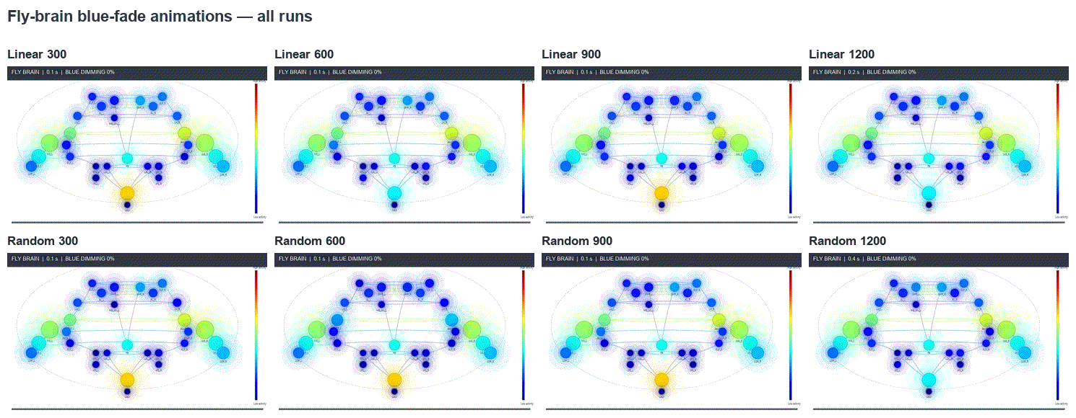
Recent references
- Erdman, P. A., Czupryniak, R., Bhandari, B., Jordan, A. N., Noé, F., Eisert, J. & Guarnieri, G. Artificially intelligent Maxwell’s demon for optimal control of open quantum systems. Quantum Science and Technology 10, 025047 (2025). https://doi.org/10.1088/2058-9565/adbccfnature+1
- Kamijima, T., Takatsu, A., Funo, K. & Sagawa, T. Optimal finite-time Maxwell’s demons in Langevin systems. Physical Review Research 7, 023159 (2025). https://doi.org/10.1103/PhysRevResearch.7.023159journals.aps
- Jin, Z., Sui, Y. et al. Whole-brain connectomic graph neural networks enable whole-body locomotion control in Drosophila. NeurIPS (2025).nature
- Liew, J. N., Lin, S., Chen, B., Zhu, X., Zhang, W. & Hu, X. Connectome-based modelling reveals orientation maps in the Drosophila optic lobe. NeurIPS (2025).pubmed.ncbi.nlm.nih
- From synapses to dynamics: obtaining function from structure in a connectome-constrained model of the head direction circuit. NeurIPS (2025).neurips
- The Drosophila connectome as a computational reservoir for time-series prediction. Biomimetics 10, 341 (2025). https://doi.org/10.3390/biomimetics10050341arxiv
- Neuromorphic simulation of Drosophila melanogaster brain connectome on Loihi 2. arXiv:2508.16792 (2025).pubmed.ncbi.nlm.nih
- Dorkenwald, S. et al. Neuronal wiring diagram of an adult brain. Nature 634, 124–138 (2024).
- Lin, A. et al. Network statistics of the whole-brain connectome of Drosophila. Nature 634, 153–165 (2024).
- Schlegel, P. et al. Whole-brain annotation and multi-connectome cell typing of Drosophila. Nature 634, 139–152 (2024).

